Warragul and district kennel and obedience dog club, inc
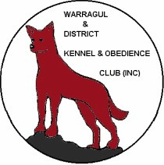 TRACKING AND SEARCH DOG TRIAL – TESTS 1 TO 5

VENUE: Burke Street Park, Warragul

DATE: Saturday 7th, Sunday 8th & Monday 9th July 2012

JUDGES: Mrs Lynn Klecka, Mrs Dawn Howard & Mrs Kim Houlden

ENTRY FEES: $40 inc. DV surcharge and catalogue

Please email entry if possible –
Use an official entry form and attach it to your email
Payments to BSB 013-735, acct 5317-21827 (C Riches), mark as TSD I will acknowledge receipt within 5 days.
Your trial information will be returned by email.

If using a postal entry, cheques payable to Warragul & Dist. K & O Club Postal entries must include a self-addressed stamped envelope for return of trial information. ( A text message or phone call to confirm safe arrival of your postal entry is advised.)

Entries to: Cate Riches PO Box 65
Boolarra, Vic 3870

Phone 5169 6632
Mobile 0427 309 008
Email flatriever@netspace.net.au

ENTRIES CLOSE; Friday 22 June 2012

CHECK IN: 7am to 7.15am. JUDGING COMMENCES: 7.30am.

If an excessive entry is received, a ballot will be held at 160 Pharaohs Road, Warragul at 7pm on Wednesday 26 June 2012

If insufficient entries are received to warrant the three days trial as scheduled, the trial will be held on Saturday and Sunday only.

